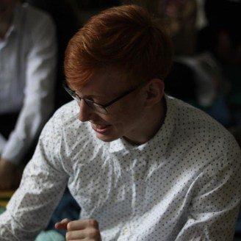
Boltach Anton Student FAMCS BSU

PERSONAL DETAILS

Birth Address Phone Mail Language
Codewars
July 01, 1999
st. October 10, Minsk (+375) 33-3900691 boltach.anton@gmail.com Russian, English
codewars.com/users/Ashes17b

TECHNICAL SKILLS

Common features

Preparation in mathematics (linear algebra, discrete mathematics, mathematical analysis, probability theory and mathematical statistics).

Understanding the basic principles of OOP.

Knowledge in algorithms and structure data.

C++

Thorough knowledge of the standard library, STL containers, and algorithms.

Knowledge of the C++11/C++14 standard and some language capabilities.

Python

Experience with the language for about six months.

EDUCATION

Belarusian State University 2016-2020 Faculty of Applied Mathematics and Computer Science, Department of Mathematical Modeling and Data Analysis
CGPA: 7.65

